About Stacked Cross Section Display

The stacked cross section is a cross section display method developed by the MGS in 2022 to replace the need to use “data-driven pages” or “map series” to filter cross section data by cross section ID. The stacked display shows all cross sections in one view, and the user only needs to drag the display up and down to move between cross sections.

This document will describe the “traditional” cross section display and when it should be used. Then, it will describe the stacked cross section display and when it should be used. Pros and cons of each display method will be described.

# Traditional Display

* Uses real-life elevation (z) for Y coordinates (in feet)
* X coordinate is calculated by:
  + Distance from “start” of cross section at western side of the project area/county (meters)
  + Vertical exaggeration factor “squishes” the x coordinate

***X = D / 0.3048 / VE***

* D = distance from “start” of cross section
* 0.3048 = convert from meters to feet
* VE = compresses X coordinates to create vertical exaggeration

Example of how the x and y coordinates look in the “traditional” display. All cross sections start at zero on the left, regardless of where the cross section is:

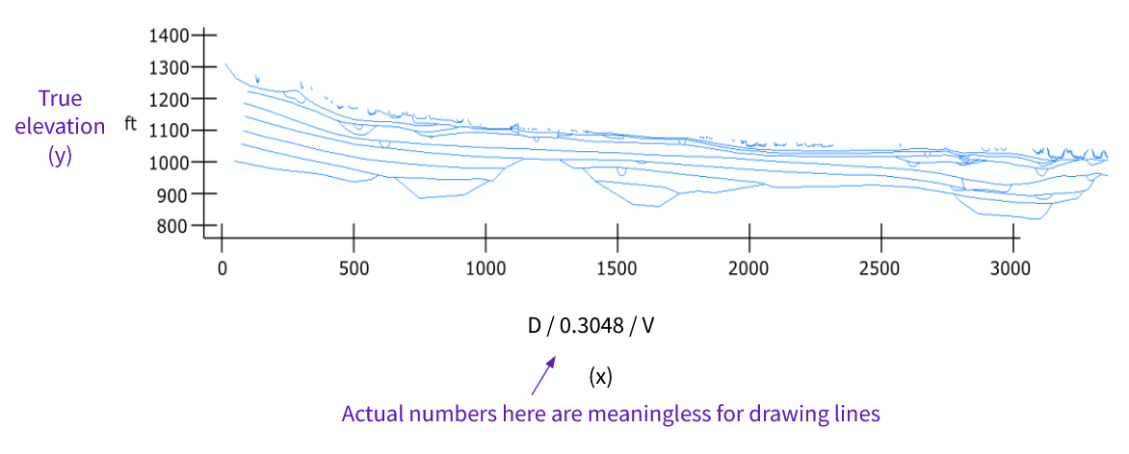

All cross sections have the same coordinates, regardless of cross section number or county. Data driven pages (or map series in Pro) are used to filter by cross section number:

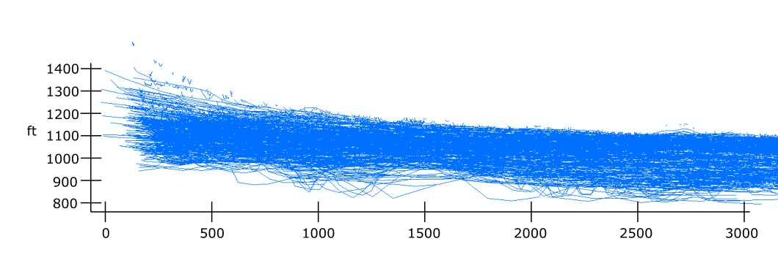

Pros of the “traditional” cross section display:

* Easy-to-see real-world elevation while drawing lines
* Simple calculation
* Runs smoothly with data driven pages
* Works with cross sections in any orientation

Problems with the “traditional” cross section display:

* Doesn’t function in ArcGIS Pro (changes in data-driven pages structure)
* Difficult to locate points along the cross section in map view
* Challenging to match cross sections with adjacent counties
* Entering et_id for every stratline drawn is confusing for quat staff
* Can be difficult to visualize north-south continuity

Traditional display should be used for:

* Cross sections that do not follow UTM latitude lines (cross sections that are not straight east-west)
* Small projects with very few cross sections (less than 5 is a good guideline)
* Compatibility with older cross section products

# Stacked Display

* Uses real-life UTM X coordinate for all data (points, lines, polygons)
* Y coordinate is calculated using:
  + True Z (elevation) coordinate
  + mn_et_id (statewide cross section ID)
  + Vertical exaggeration

***Y = (((z * 0.3048) - (700 * mn_et_id)) * VE) + 23,100,000***

* Z = true elevation (feet)
* 0.3048 = convert from feet to meters
* 700 = arbitrary constant to vertically space cross section with no overlap
* VE = vertical exaggeration
* 23,100,000 = arbitrary constant to keep all coordinates above zero

The “stacked” display will plot cross sections in the same order as the county ‘et_id’, that is, north to south. The minus sign in the equation makes this happen. There are 2 arbitrary constants: the number 700 will vertically space all of the cross sections with no overlap, and works in all counties in MN regardless of sediment thickness or topographic relief. The number 23,100,000 is added at the end of the coordinate to keep all coordinates statewide above zero. This helps to avoid “out of extent” errors when creating data.

This is an example (Chippewa County) which shows how the map view cross section lines get spaced out in the stacked system. The coordinates are calculated with the statewide cross section number (mn_et_id), but the display shows county cross section number (et_id).

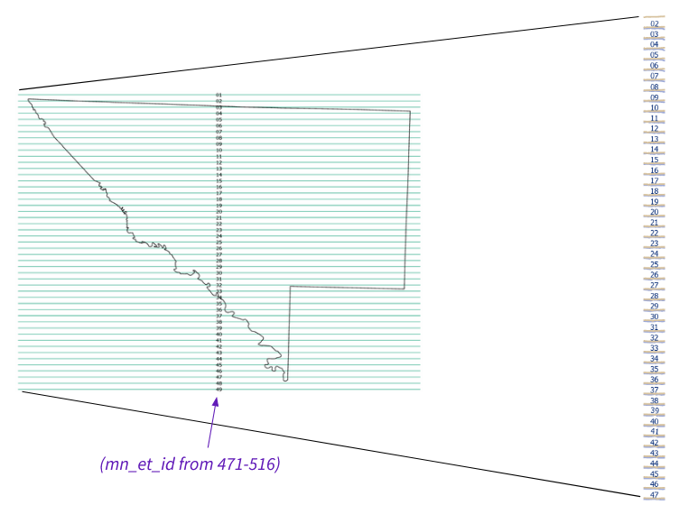

Below is a close-up view of how one cross section will look, showing x and y coordinates. X coordinates exactly match x coordinates in mapview. Y coordinates are meaningless. The geologist will scroll up and down to change cross section:

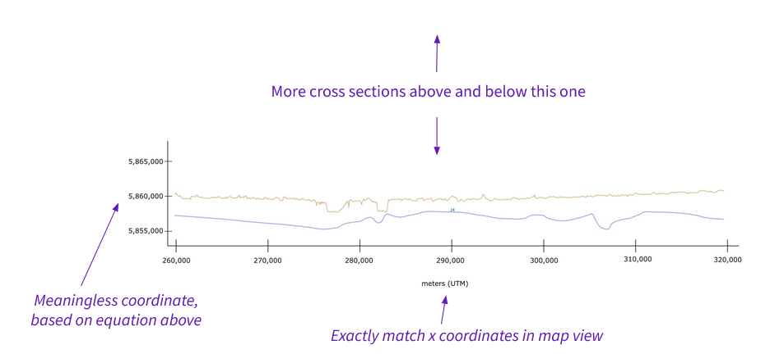

Below is a close-up example of how the editing display looks in ArcGIS Pro:

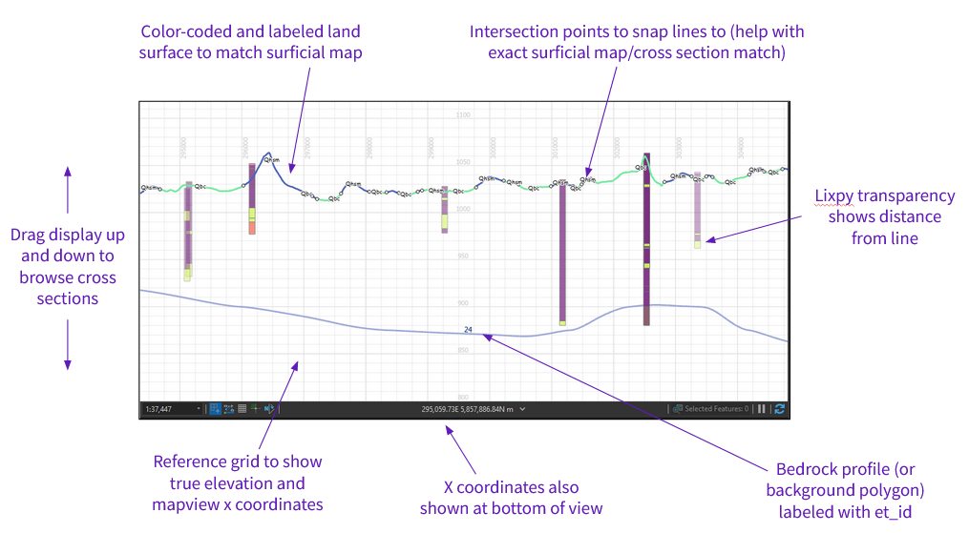

Since the X coordinates represent true UTM coordinates, and since cross sections are plotted vertically relative to statewide ID, adjacent counties can be loaded into the same map and will match up automatically.

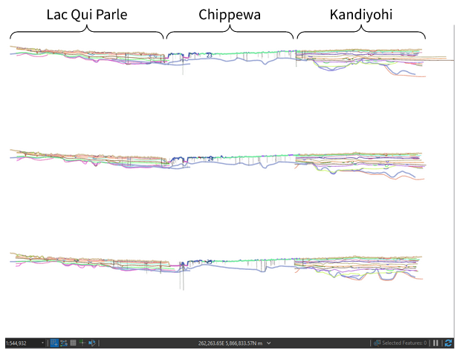

Pros of the “stacked” cross section display

* Works in ArcPro and ArcMap
* No et_id needed during editing
* True X coordinates: easy to match exact location in map view
* Easy to display data from adjacent counties
* Easier to visualize north-south continuity in cross section units (hopefully?)

Problems with the “stacked” cross section display

* Only works for straight east-west cross sections (no diagonal)
* Confusing transition time anticipated
* Will need to edit scripts
* Compatibility with DNR?

Stacked display should be used for:

* Cross sections that precisely follow UTM latitude lines (cross sections that are straight east-west)
* Projects with many cross sections that are evenly spaced (i.e., MGS county geologic atlas quaternary cross sections)

Solutions to anticipated problems

* Conversion tools to switch between cross section systems: works with point, line, and polygon data. Will help with transition time, and could help with DNR compatibility
* Maintain “traditional” display for bedrock geologists (and other cases) to allow for cross sections in different orientations
* Tool that will automatically assign et_id and mn_et_id to data that is created by geologist (i.e., stratlines)
* Tool that will take data drawn in one cross section and display it on all cross sections